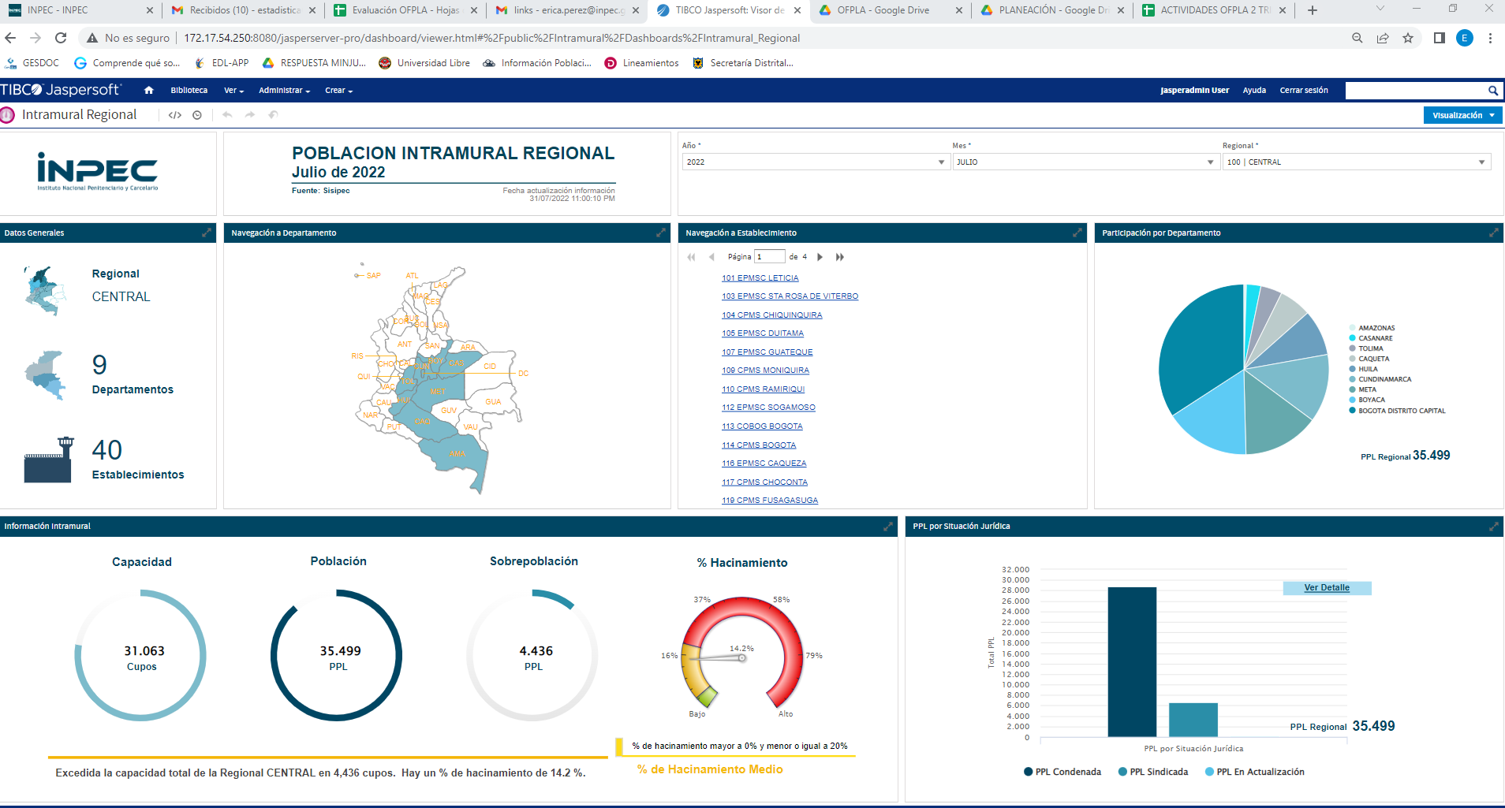
http://172.17.54.250:8080/jasperserver-pro/dashboard/viewer.html#%2Fpublic%2FIntramural%2FDashboards%2FIntramural_Regional

